
ABOUT THE BOOK
There’s this idea going around that we’re always supposed to be happy—and it’s making us miserable. The good news is, if you can learn to let go of that impossible expectation, your life will be a whole lot happier. Acceptance and Commitment Therapy (ACT) is a simple, self-administered therapy that uses mindfulness to enable you to do just that. This fun, illustrated guide to the method that’s made life better for millions is the easiest way yet to learn how to escape the happiness trap and start living a life that’s more rewarding, more meaningful—and happier.
With ACT you’ll learn to:
Reduce stress and worry
Handle painful feelings and thoughts more effectively
Break self-defeating habits
Overcome insecurity and self-doubt
Recognize and treasure the whole range of emotions that make up a satisfying life
Dr. RUSS HARRIS is a physician, therapist, and speaker specializing in stress management. He travels nationally and internationally to train individuals and health professionals in the techniques of ACT. Born and educated in England, he now lives in Australia. For more information, visit actmindfully.com.au.
2

Visit us online at
shambhala.com/eshambhala
to receive news and special offers from Shambhala Publications.
3
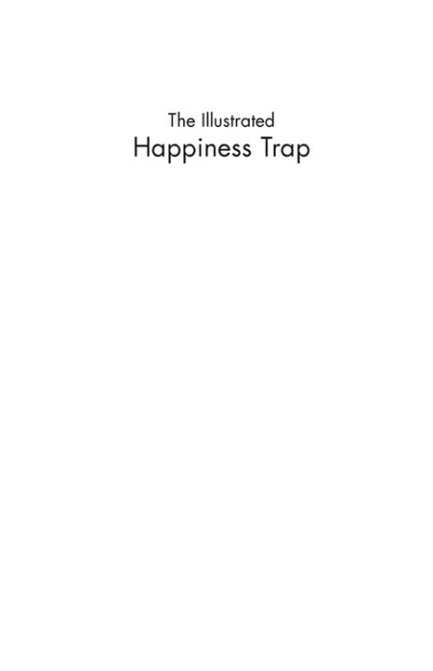4
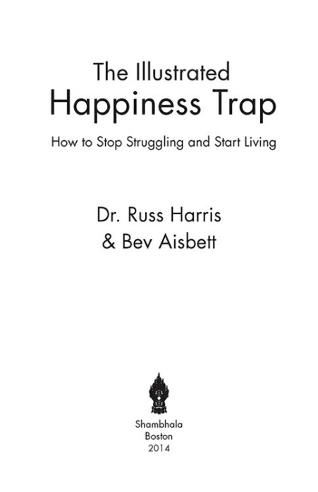5
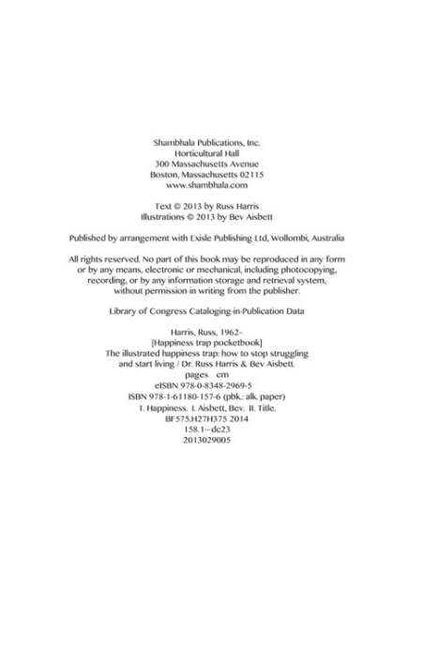6
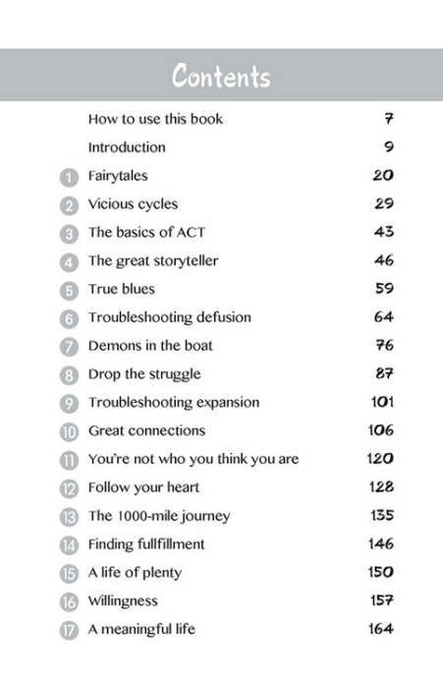7
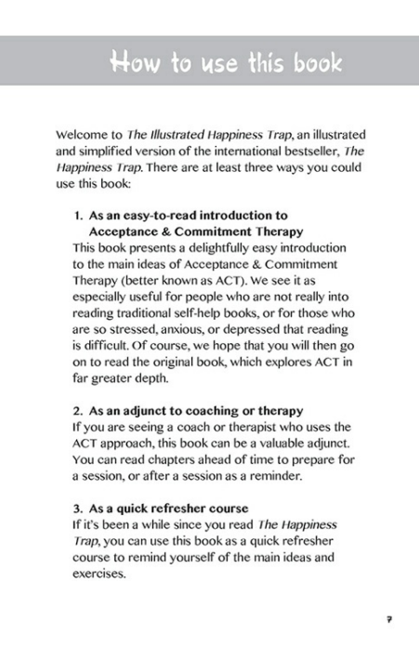8
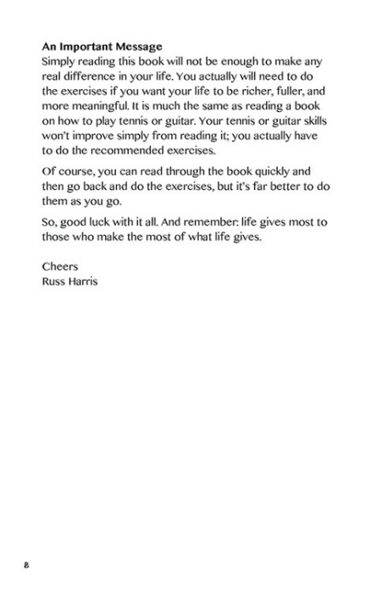9
10
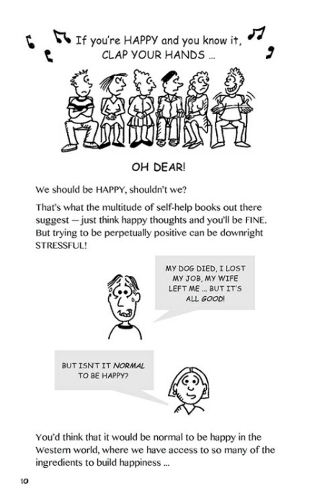11
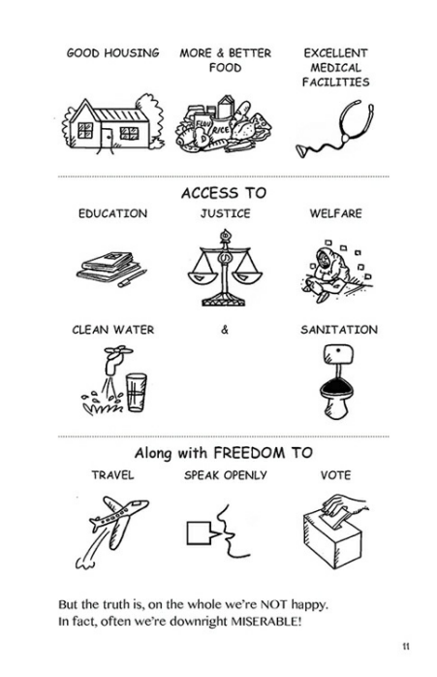12
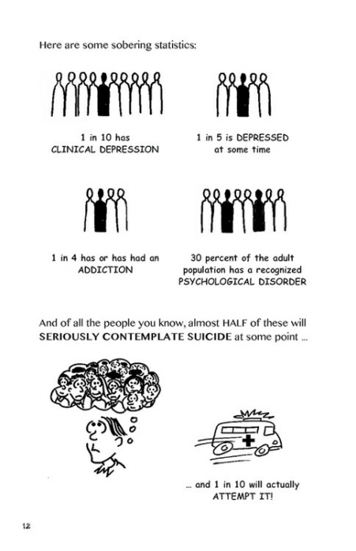13
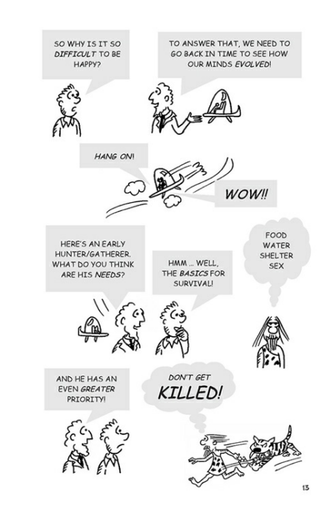14
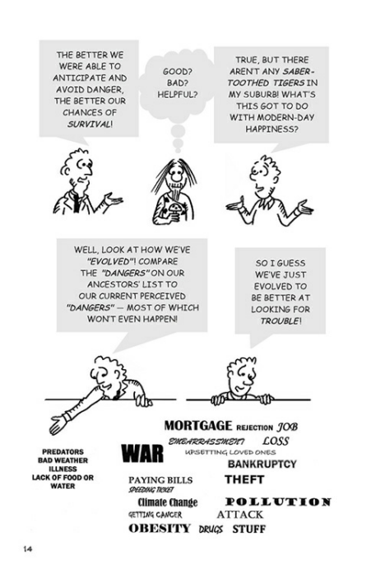15
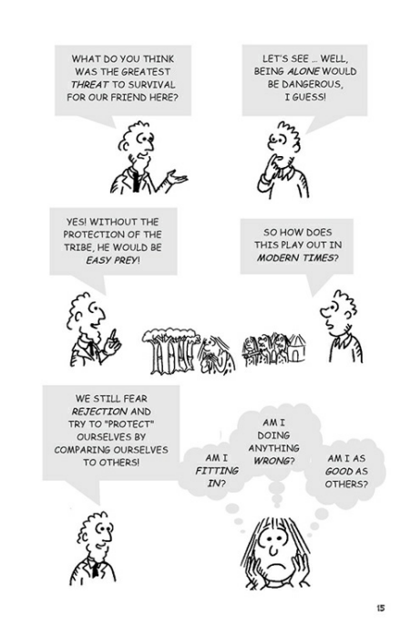16
17
18
19
20
21
22
23
24
25
26
27
28
29
30
31
32
33
34
35
36
37
38
39
40
41
42
43
44
45
46
47
48
49
50
51
52
53
54
55
56
57
58
59
60
61
62
63
64
65
66
67
68
69
70
71
72
73
74
75
76
77
78
79
80

